Count the Digits That Divide a Number
Platform: Leetcode
Language: C
Module 4, Question 4

Problem Link
https://leetcode.com/problems/count-the-digits-that-divide-a-number/description/

Problem Statement
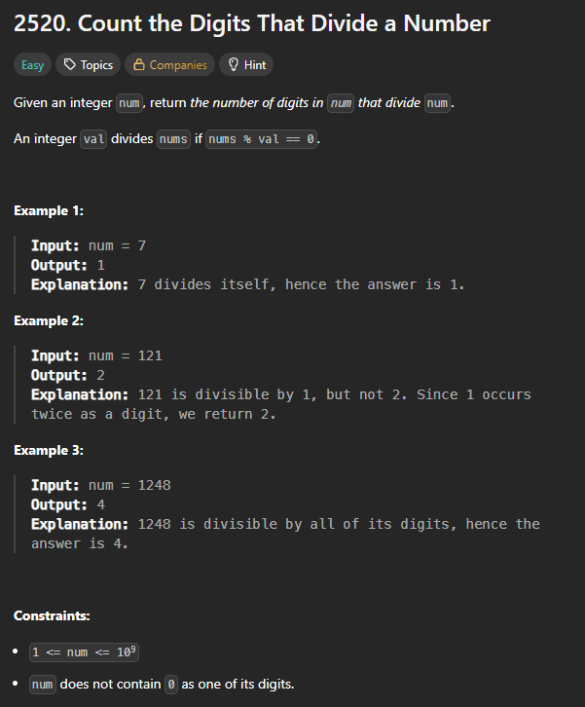

C Code
int countDigits(int num) {
int temp = num, count = 0;
while (temp > 0) {
int d = temp % 10;
if (num % d == 0) // the problem guarantees num has no 0 digit
count++;
temp /= 10;
}
return count;
}

Screenshot of Successful Submission



